Exploratory testing for web page <http://www.007museum.com/>

|  |  |
| --- | --- |
| **Browser** | Chrome Version 89.0.4389.114 (64-bit) |
| **Device & Operating System** | Lenovo ThinkPad W541 Windows 10 |
| **Testing** | Manual |
| **Title** | **Multiple Facebook links (icons) under main image on homepage** |
| **Severity** | Medium |
| **Priority** | Medium |
| **Description** | Content bug three Facebook icons in one row |
| **Steps to reproduce** | 1. Open Chrome browser 2. Navigate to “ <http://www.007museum.com/>“ 3. Scroll down below main black image |
| **Expected result** | One Facebook icon |
| **Actual result** | Multiple Facebook icons |

Screenshot:

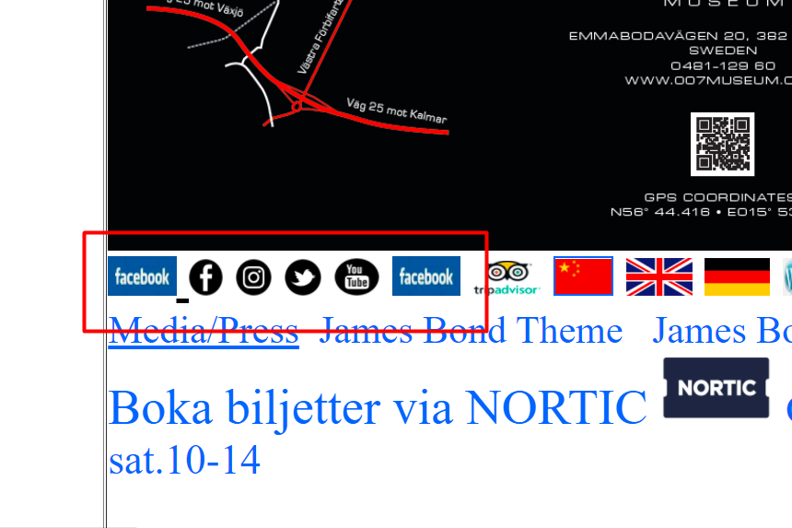

|  |  |
| --- | --- |
| **Browser** | Chrome Version 89.0.4389.114 (64-bit) |
| **Device & Operating System** | Lenovo ThinkPad W541 Windows 10 |
| **Testing** | Manual |
| **Title** | **Text layout of the Open hours is spread** |
| **Severity** | Low |
| **Priority** | High |
| **Description** | Visual problem of the Open hours of the museum, Friday is on the right side, Saturday on the left in the next row. |
| **Steps to reproduce** | 1. Open Chrome browser 2. Navigate to “ <http://www.007museum.com/>“ 3. Scroll down below main black image |
| **Expected result** | Open hours of days are aligned |
| **Actual result** | Open hours of days are splitted |

Screenshot:

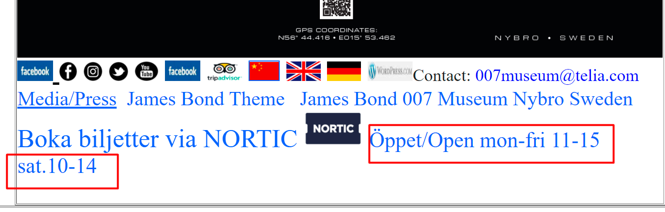

|  |  |
| --- | --- |
| **Browser** | Chrome Version 89.0.4389.114 (64-bit) |
| **Device & Operating System** | Lenovo ThinkPad W541 Windows 10 |
| **Testing** | Manual |
| **Title** | **Homepage is too long** |
| **Severity** | Medium |
| **Priority** | High |
| **Description** | Visual problem of the homepage. It is too LONG |
| **Steps to reproduce** | 1. Open Chrome browser 2. Navigate to “ <http://www.007museum.com/>“ 3. Scroll down until you get to the bottom of the page |
| **Expected result** | Smaller homepage |
| **Actual result** | Very long homepage |

|  |  |
| --- | --- |
| **Browser** | Chrome Version 89.0.4389.114 (64-bit) |
| **Device & Operating System** | Lenovo ThinkPad W541 Windows 10 |
| **Testing** | Manual |
| **Title** | **Images on the homepage are too big** |
| **Severity** | Medium |
| **Priority** | Medium |
| **Description** | Visual problem of the images on the homepage |
| **Steps to reproduce** | 1. Open Chrome browser 2. Navigate to “ <http://www.007museum.com/>“ 3. Scroll down through the homepage |
| **Expected result** | Smaller images |
| **Actual result** | Very large images, taking to much space on the page |

Screenshot:

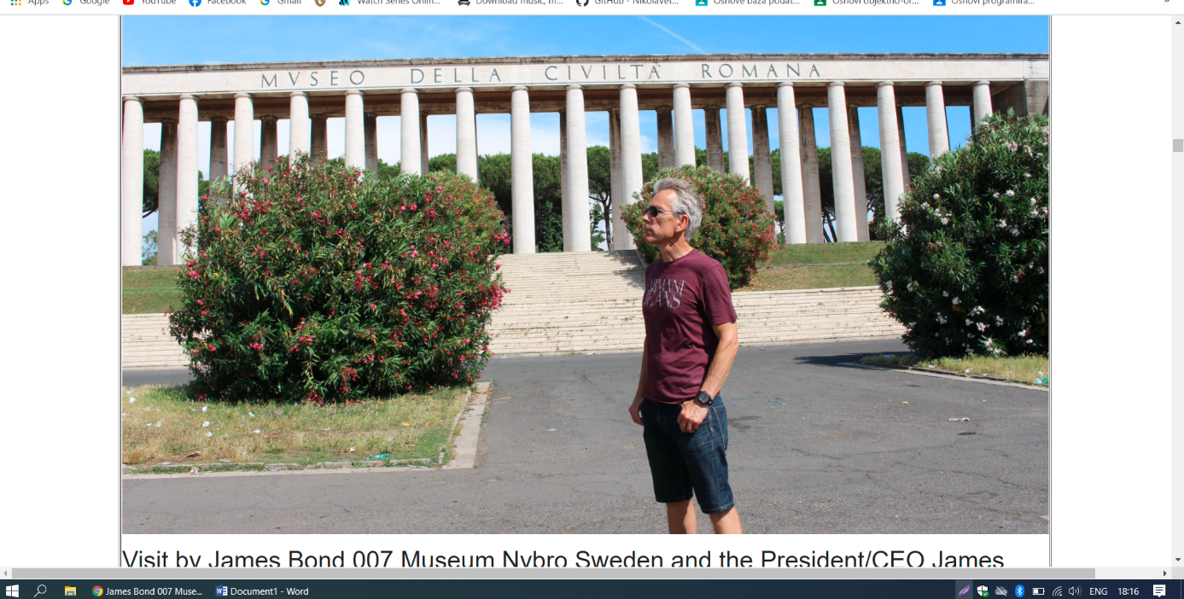

|  |  |
| --- | --- |
| **Browser** | Chrome Version 89.0.4389.114 (64-bit) |
| **Device & Operating System** | Lenovo ThinkPad W541 Windows 10 |
| **Testing** | Manual |
| **Title** | **Font size of the text on homepage is too big** |
| **Severity** | Medium |
| **Priority** | Medium |
| **Description** | Font size of the multiple texts and articles on the homepage is too big. |
| **Steps to reproduce** | 1. Open Chrome browser 2. Navigate to “ <http://www.007museum.com/>“ 3. Scroll down through the homepage |
| **Expected result** | Consistent smaller font size |
| **Actual result** | Font size too big |

Screenshot:

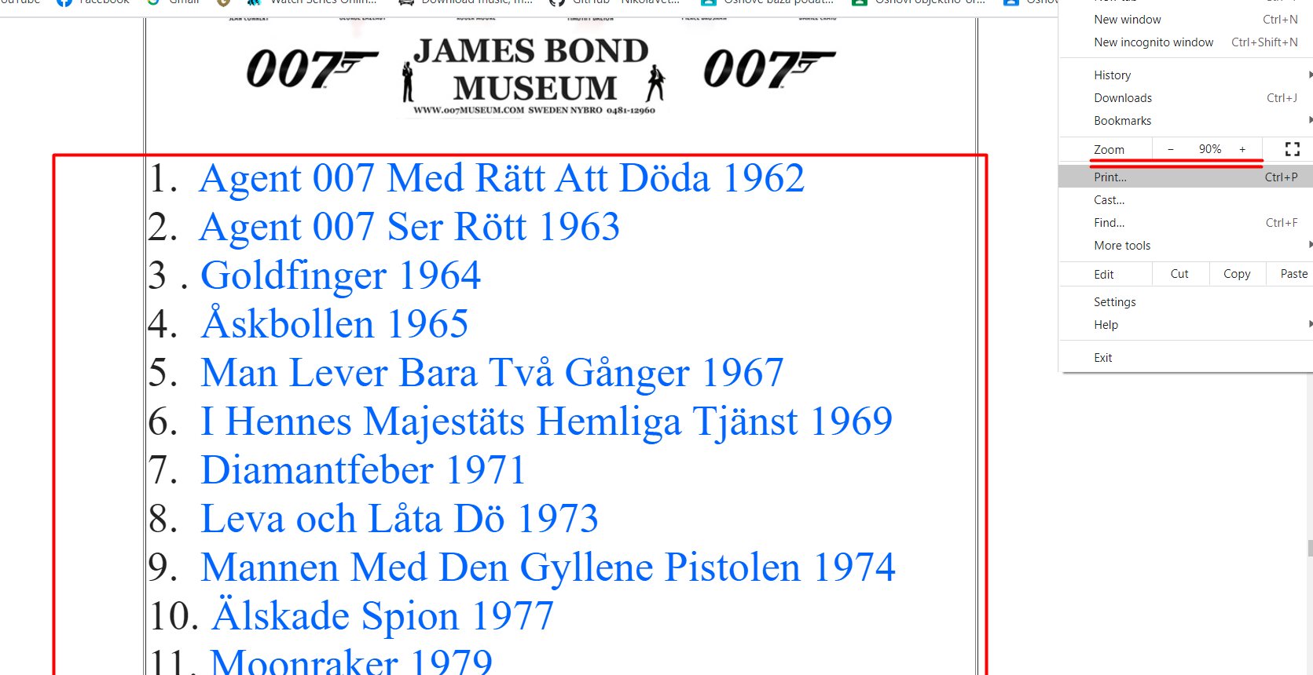

|  |  |
| --- | --- |
| **Browser** | Chrome Version 89.0.4389.114 (64-bit) |
| **Device & Operating System** | Lenovo ThinkPad W541 Windows 10 |
| **Testing** | Manual |
| **Title** | **First video link plays music instead of the real content.** |
| **Severity** | Medium |
| **Priority** | High |
| **Description** | The content of the video is feature story but video plays some kind of music |
| **Steps to reproduce** | 1. Open Chrome browser 2. Navigate to “ <http://www.007museum.com/>“ 3. Scroll down to the first video on the left 4. Play the video |
| **Expected result** | Actual content of the video is played |
| **Actual result** | Music is played |

Video link:

<https://recordit.co/mQvoywVsEN>

|  |  |
| --- | --- |
| **Browser** | Chrome Version 89.0.4389.114 (64-bit) |
| **Device & Operating System** | Lenovo ThinkPad W541 Windows 10 |
| **Testing** | Manual |
| **Title** | **Automatically downloads “bond-svt-sr.wma” file when clicked on Open hours in homepage** |
| **Severity** | High |
| **Priority** | High |
| **Description** | When you click on the Open hours link on the homepage it sends you to that page but automatically downloads “bond-svt-sr.wma” file. |
| **Steps to reproduce** | 1. Open Chrome browser 2. Navigate to “ <http://www.007museum.com/>“ 3. Scroll down to the **Ö**ppet/Open link below the black image 4. Click on the **Ö**ppet/Open link |
| **Expected result** | Open the page |
| **Actual result** | Opens the page and downloads the file |

Video link:

<https://recordit.co/okeuo4ITwM>

|  |  |
| --- | --- |
| **Browser** | Chrome Version 89.0.4389.114 (64-bit) |
| **Device & Operating System** | Lenovo ThinkPad W541 Windows 10 |
| **Testing** | Manual |
| **Title** | **“404 Not Found” appears when clicking on the black image on the “TRIUMPH_SCRAMBLER_1200_BOND_EDITION” page** |
| **Severity** | High |
| **Priority** | High |
| **Description** | A content issue appears when you click on the cover black image on the “triumph scrambler 1200 bond edition” page |
| **Steps to reproduce** | 1. Open Chrome browser 2. Navigate to “ <http://www.007museum.com/>“ 3. Scroll down to the “TRIUMPH SCRAMBLER 1200 BOND EDITION No Time To Die” link and click to open 4. Click on the big black cover image |
| **Expected result** | Open the URL |
| **Actual result** | 404 Not Found window appears |

Video link:

<https://recordit.co/0b3eCvEwMf>

|  |  |
| --- | --- |
| **Browser** | Chrome Version 89.0.4389.114 (64-bit) |
| **Device & Operating System** | Lenovo ThinkPad W541 Windows 10 |
| **Testing** | Manual |
| **Title** | **Preview images are too small** |
| **Severity** | Low |
| **Priority** | Medium |
| **Description** | Visual issue of some images under the big image of Daniel Craig in tuxedo |
| **Steps to reproduce** | 1. Open Chrome browser 2. Navigate to “ <http://www.007museum.com/>“ 3. Scroll down to the images after the big image of Daniel Craig in the tuxedo |
| **Expected result** | Larger images |
| **Actual result** | Two small images |

Screenshot:

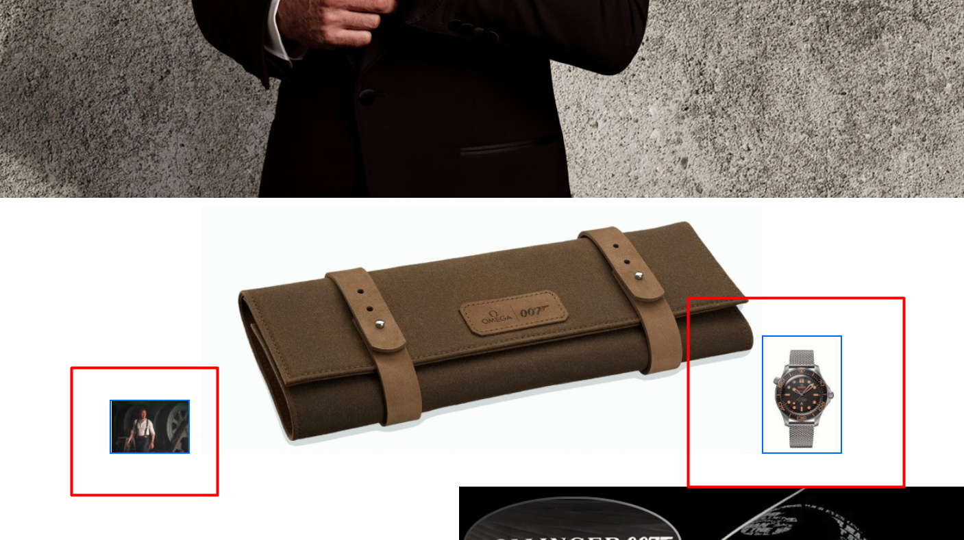

|  |  |
| --- | --- |
| **Browser** | Chrome Version 89.0.4389.114 (64-bit) |
| **Device & Operating System** | Lenovo ThinkPad W541 Windows 10 |
| **Testing** | Manual |
| **Title** | **Texts are overlapping each other** |
| **Severity** | Medium |
| **Priority** | High |
| **Description** | Visual issue of some text on the page. Two texts are mixed and overlapping each other |
| **Steps to reproduce** | 1. Open Chrome browser 2. Navigate to “ <http://www.007museum.com/>“ 3. Scroll down to the bottom of the page 4. Click on the address link of the museum “[James Bond 007 Museum, Emmabodav. 20  382 45 Nybro, Sweden](http://www.007museum.com/nybroatlas.htm)   0481-12960” 5. Scroll down to the middle of the opened page |
| **Expected result** | Regular text article |
| **Actual result** | Two text are overlapping each other |

Screenshot:

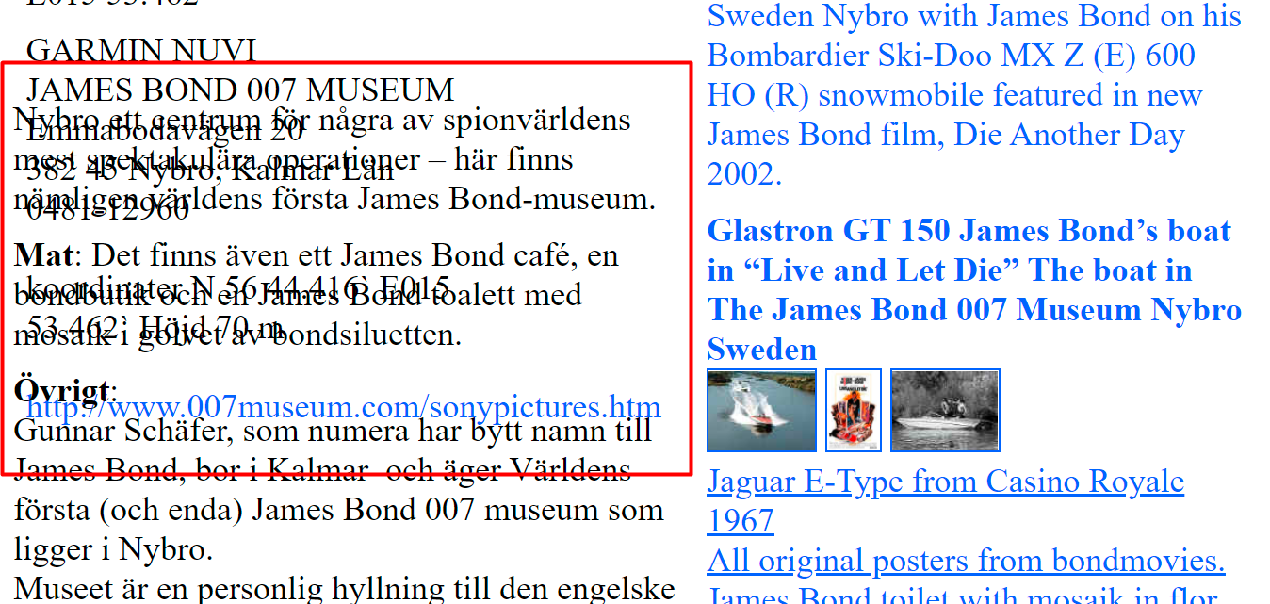

|  |  |
| --- | --- |
| **Browser** | Chrome Version 89.0.4389.114 (64-bit) |
| **Device & Operating System** | Lenovo ThinkPad W541 Windows 10 |
| **Testing** | Manual |
| **Title** | **Textboxes are not aligned** |
| **Severity** | Low |
| **Priority** | Low |
| **Description** | Visual issue of some textboxes on the page. They are not aligned. |
| **Steps to reproduce** | 1. Open Chrome browser 2. Navigate to “ <http://www.007museum.com/>“ 3. Scroll down to the middle of the page and continue scrolling down the page |
| **Expected result** | Aligned textboxes |
| **Actual result** | Textboxes not aligned |

Screenshot:

t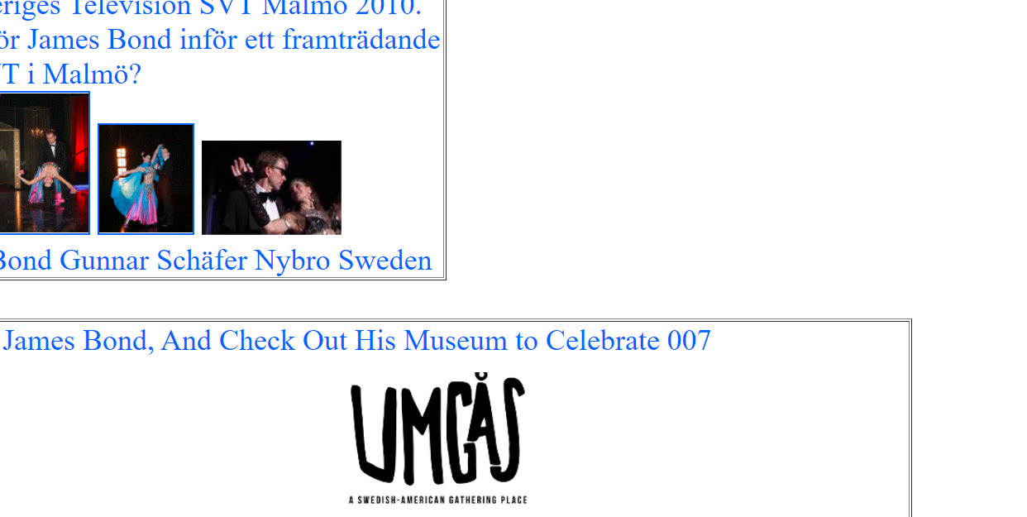

|  |  |
| --- | --- |
| **Browser** | Chrome Version 89.0.4389.114 (64-bit) |
| **Device & Operating System** | Lenovo ThinkPad W541 Windows 10 |
| **Testing** | Manual |
| **Title** | **Too much white spaces on the homepage** |
| **Severity** | Low |
| **Priority** | Low |
| **Description** | Visual issue of white space through the homepage |
| **Steps to reproduce** | 1. Open Chrome browser 2. Navigate to “ <http://www.007museum.com/>“ 3. Scroll down through the page |
| **Expected result** | No white space on the page |
| **Actual result** | A lot of white space on the page |

Screenshot:

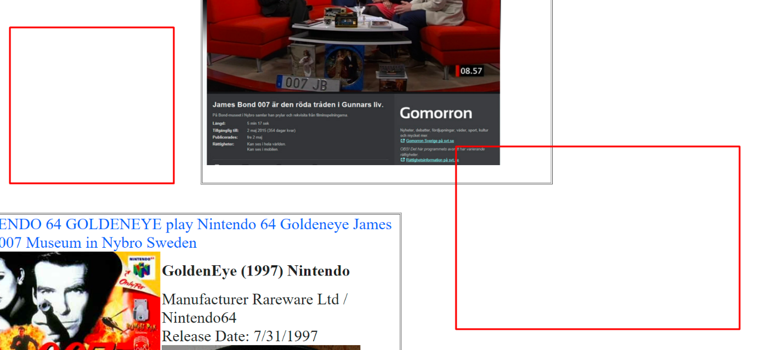

|  |  |
| --- | --- |
| **Browser** | Chrome Version 89.0.4389.114 (64-bit) |
| **Device & Operating System** | Lenovo ThinkPad W541 Windows 10 |
| **Testing** | Manual |
| **Title** | **Ticket prices are not defined correctly** |
| **Severity** | Medium |
| **Priority** | High |
| **Description** | Content issue of ticket prices for pensioners are not defined correctly. For adults and children prices are in euros but not for the pensioners |
| **Steps to reproduce** | 1. Open Chrome browser 2. Navigate to “ <http://www.007museum.com/>“ 3. Scroll down to the bottom of the page 4. Click on the museum address link 5. Check the entry ticket prices |
| **Expected result** | Defined prices for everyone |
| **Actual result** | Prices not defined |

Screenshot:

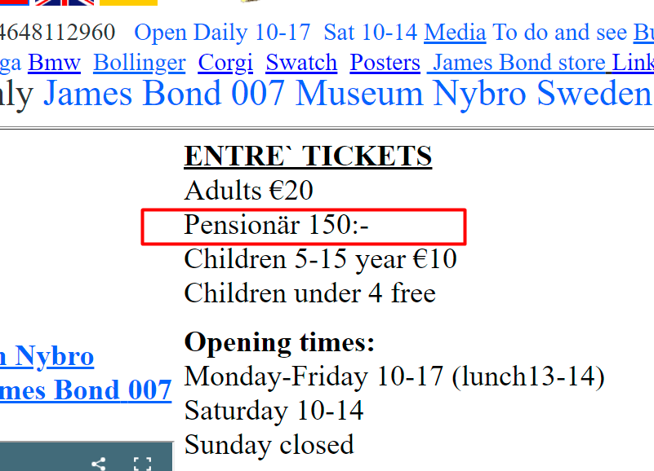

Exploratory testing for web page <https://www.arngren.net/>

|  |  |
| --- | --- |
| **Browser** | Chrome Version 89.0.4389.114 (64-bit) |
| **Device & Operating System** | Lenovo ThinkPad W541 Windows 10 |
| **Testing** | Manual |
| **Title** | **Too many compacted items on the page** |
| **Severity** | Medium |
| **Priority** | Medium |
| **Description** | Visual issue of the items on the page. The items are compacted. |
| **Steps to reproduce** | 1. Open Chrome browser 2. Navigate to “<https://www.arngren.net/> “ 3. Scroll through the page and check the items |
| **Expected result** | Nicely arranged items |
| **Actual result** | Compacted items |

|  |  |
| --- | --- |
| **Browser** | Chrome Version 89.0.4389.114 (64-bit) |
| **Device & Operating System** | Lenovo ThinkPad W541 Windows 10 |
| **Testing** | Manual |
| **Title** | **Item images too small** |
| **Severity** | Medium |
| **Priority** | Medium |
| **Description** | Visual issue of the item images on the page. The items are too small |
| **Steps to reproduce** | 1. Open Chrome browser 2. Navigate to “<https://www.arngren.net/> “ 3. Scroll through the page and check the item images |
| **Expected result** | Bigger images |
| **Actual result** | Very small images |

|  |  |
| --- | --- |
| **Browser** | Chrome Version 89.0.4389.114 (64-bit) |
| **Device & Operating System** | Lenovo ThinkPad W541 Windows 10 |
| **Testing** | Manual |
| **Title** | **Missing content on the page** |
| **Severity** | High |
| **Priority** | High |
| **Description** | Content issue on the linked page |
| **Steps to reproduce** | 1. Open Chrome browser 2. Navigate to “<https://www.arngren.net/> “ 3. Click on the “Alarm” link on the top left side of the page |
| **Expected result** | Items on the page |
| **Actual result** | No items on the page |

|  |  |
| --- | --- |
| **Browser** | Chrome Version 89.0.4389.114 (64-bit) |
| **Device & Operating System** | Lenovo ThinkPad W541 Windows 10 |
| **Testing** | Manual |
| **Title** | **Text overlapping when page language is changed to English** |
| **Severity** | High |
| **Priority** | High |
| **Description** | Visual issue when page language is changed to English. Texts are overlapping. |
| **Steps to reproduce** | 1. Open Chrome browser 2. Navigate to “<https://www.arngren.net/> “ 3. Change the page language to English |
| **Expected result** | Text not overlapping when language is changed |
| **Actual result** | Text is overlapping |

Screenshot:

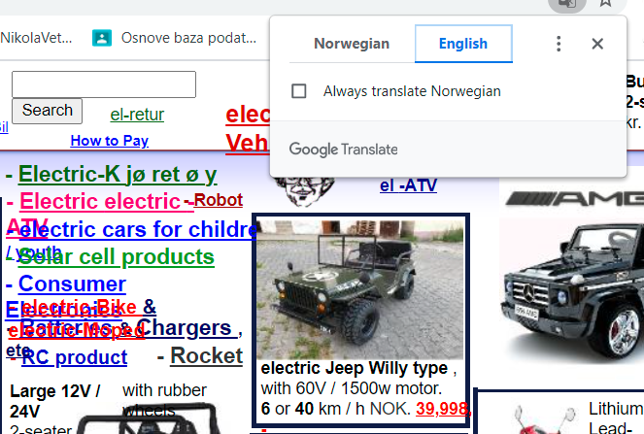

|  |  |
| --- | --- |
| **Browser** | Chrome Version 89.0.4389.114 (64-bit) |
| **Device & Operating System** | Lenovo ThinkPad W541 Windows 10 |
| **Testing** | Manual |
| **Title** | **Page contact info is placed between the items and it’s not visible** |
| **Severity** | Medium |
| **Priority** | Medium |
| **Description** | Visual issue of the contact information is not visible. It is placed between the items. |
| **Steps to reproduce** | 1. Open Chrome browser 2. Navigate to “<https://www.arngren.net/> “ 3. Scroll to the bottom of the page 4. Check the top left side for contact info |
| **Expected result** | Contact info should be in the better position on the page so that it can be seen |
| **Actual result** | Contact info is placed between the items |

Screenshot:

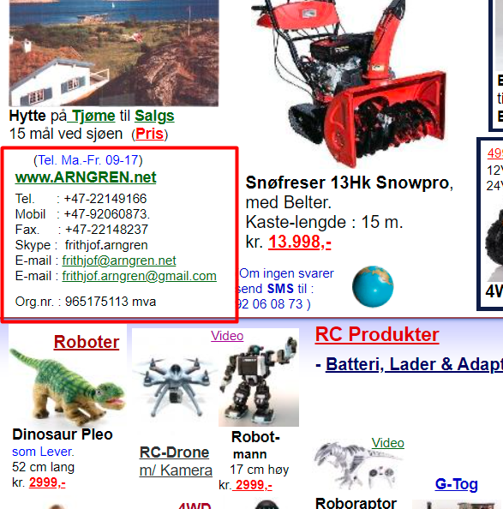

|  |  |
| --- | --- |
| **Browser** | Chrome Version 89.0.4389.114 (64-bit) |
| **Device & Operating System** | Lenovo ThinkPad W541 Windows 10 |
| **Testing** | Manual |
| **Title** | **Second search box button on the bottom side between items** |
| **Severity** | Medium |
| **Priority** | Medium |
| **Description** | Visual issue of the second search box on the page. It is placed between the items on the bottom of the page. |
| **Steps to reproduce** | 1. Open Chrome browser 2. Navigate to “<https://www.arngren.net/> “ 3. Scroll to the bottom of the page |
| **Expected result** | No search box between the items |
| **Actual result** | Search box is placed between the items |

Screenshot:

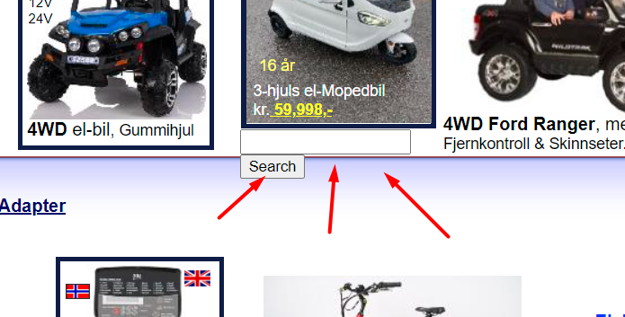

|  |  |
| --- | --- |
| **Browser** | Chrome Version 89.0.4389.114 (64-bit) |
| **Device & Operating System** | Lenovo ThinkPad W541 Windows 10 |
| **Testing** | Manual |
| **Title** | **“404 URL not found” appears when clicked on a small rotating globe on the bottom of the page** |
| **Severity** | Critical |
| **Priority** | High |
| **Description** | Content issue of broken link |
| **Steps to reproduce** | 1. Open Chrome browser 2. Navigate to “<https://www.arngren.net/> “ 3. Scroll to the bottom of the page 4. Click on a small rotating globe |
| **Expected result** | Link works and sends user to the page |
| **Actual result** | Link is broken |

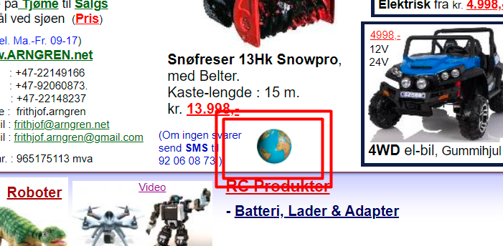

|  |  |
| --- | --- |
| **Browser** | Chrome Version 89.0.4389.114 (64-bit) |
| **Device & Operating System** | Lenovo ThinkPad W541 Windows 10 |
| **Testing** | Manual |
| **Title** | “This site can’t be reached“ appears when clicked on small playboy magazine image |
| **Severity** | Critical |
| **Priority** | High |
| **Description** | Content issue of broken link. |
| **Steps to reproduce** | 1. Open Chrome browser 2. Navigate to “<https://www.arngren.net/> “ 3. Scroll to the bottom right side of the page 4. Click on a small playboy magazine image that is placed next to the rotating globe |
| **Expected result** | Link works and sends user to the page |
| **Actual result** | Link is broken |

Screenshot:

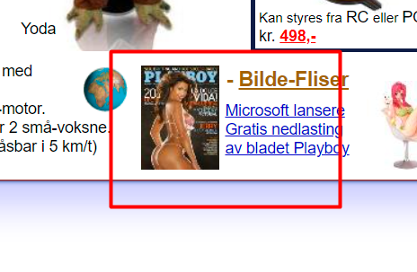

|  |  |
| --- | --- |
| **Browser** | Chrome Version 89.0.4389.114 (64-bit) |
| **Device & Operating System** | Lenovo ThinkPad W541 Windows 10 |
| **Testing** | Manual |
| **Title** | **Too much white spaces on the homepage** |
| **Severity** | Low |
| **Priority** | Low |
| **Description** | Visual issue of white space through the homepage |
| **Steps to reproduce** | 1. Open Chrome browser 2. Navigate to “<https://www.arngren.net/> “ 3. Scroll to the right side of the page 4. Scroll down the page |
| **Expected result** | No white space on the page |
| **Actual result** | A lot of white space on the page |

Screenshot:

